

FOR IMMEDIATE RELEASE

HENRY SCHEIN RECEIVES
HENRY KAUFMANN CAMPGROUNDS CORPORATE LEADER AWARD

Company Recognized for its Commitment to Community Outreach

MELVILLE, N.Y., June 12, 2015 – Henry Schein, Inc. (NASDAQ: HSIC), the world’s largest provider of health care products and services to office-based dental, animal health and medical practitioners, announced today that it has been selected as the recipient of the Corporate Leader Award of the Henry Kaufmann Campgrounds (HKC). HKC is a beneficiary agency of UJA-Federation of New York (UJA-Federation) and home to 16 Jewish day camps operated by Jewish Community Centers in the greater New York area. Henry Schein was honored on June 10 at HKC’s Annual One Camp Community Celebration held at Citi Field in New York City, and sponsored by David Katz, President of the Henry Kaufmann Campgrounds and Partner of the New York Mets.
The Company was recognized for its commitment to community outreach through its donation of oral health care products, including toothbrushes, toothpaste and dental floss, in support of HKC’s 2015 Act of Kindness project. These donated products will be used to create thousands of personal health kits, which will be provided to nearly 3,600 underserved children on Long Island through UJA-Federation’s Supplies for Success program, which for 14 years has ensured that children without means, from kindergarten through 12th grade, return to the classroom with new book bags containing age-appropriate supplies. The personal health kits will be assembled by HKC’s campers during an assembly-and-pack drive and will be added to the backpacks. Established by UJA-Federation’s Long Island’s Connections division in 2001, Supplies for Success helps more than 10,000 children belonging to UJA-Federation beneficiary agencies, schools, shelters and other local organizations each year.
“Henry Schein is honored to be recognized by the Henry Kaufmann Campgrounds, which offers children wonderful recreational experiences, a welcoming environment and instills the values of respect for others, community, family, and helping those in need—all values that our Company shares,” said
Michael S. Ettinger, Henry Schein’s Senior Vice President of Corporate & Legal Affairs, who accepted the award on the Company’s behalf. “Henry Schein’s support of HKC’s Act of Kindness Project reflects our commitment to community outreach and corporate social responsibility through Henry Schein Cares – our Company’s global corporate social responsibility program – through which we expand access to care for underserved populations.
-more-
Page 2

We look forward to continuing to work with the Henry Kaufmann Campgrounds on initiatives like HKC’s Act of Kindness program, Supplies for Success, and other meaningful outreach endeavors.”
Henry Schein has a long history of supporting programs to help children return to the classroom prepared to succeed. In addition to its support of HKC’s Act of Kindness project and UJA-Federation’s Supplies for Success initiative, since 1998 Henry Schein has held its annual “Back to School” program, which has benefited more than 27,000 underserved children since the program’s inception. Through “Back to School,” a flagship initiative of Henry Schein Cares, children at many participating Company locations receive school essentials ranging from new first-day outfits that are personally selected and paid for by Team Schein Members, to backpacks filled with classroom supplies, books and hygiene products. Each year, Henry Schein partners with local social service organizations to help identify children and families who would benefit from participation in the “Back to School” program. “Back to School” is also supported by the Henry Schein Cares Foundation, Inc., a 501(c)(3) organization that works to help increase access to health care in underserved communities around the world.
“We are delighted to honor Henry Schein with our Corporate Leader Award,” said Mr. Katz. “The Company’s generous donation provides the foundation for each camp to corral their communities to donate additional products to create the personal health kits. Because of Henry Schein’s generosity, HKC is able to coordinate its first ever camp-wide project that will encompass 3,600 campers from New York City, Long Island and Rockland and Westchester counties.”
Rosemarie Klipper, a Henry Kaufmann Campgrounds Board Member, presented the award to Mr. Ettinger. “This is a wonderful opportunity to inspire our young generation of campers to be kind. Thanks to Henry Schein’s support of programs like these, the Henry Kaufmann Campgrounds can live up to our mission of enhancing the day camp experience and integrating Jewish values such as ‘tikkun olam,’ repairing the world, into campers’ experiences, helping them understand that it is up to each one of them to do their part to help those who are less fortunate.”

About the Henry Kaufmann Campgrounds
An affiliate of UJA-Federation of New York, the Henry Kaufmann Campgrounds enhances the day camp experience while promoting Jewish values and providing a safe environment for the campers and counselors of the 16 independent day camps who call our grounds home. Each summer we welcome more than 5000 campers and staff daily from New York City, Long Island, Rockland and Westchester counties to our three sites. For more information, please visit the Henry Kaufmann Campgrounds’ website at www.camphkc.org.

-more-

Page 3
About UJA-Federation of New York
For more than 95 years, UJA-Federation has inspired New Yorkers to act on their values and
invest in our community for the biggest impact. Through UJA-Federation, more than 50,000 donors
address issues that matter most to them, pooling their resources to care for New Yorkers of all
backgrounds and Jews everywhere, to connect people to their Jewish communities, and to respond to crises close to home and around the globe. Working with nearly 100 beneficiary agencies, synagogues, and other Jewish organizations, UJA-Federation is the world’s largest local philanthropy; our reach spans from New York to Israel to more than 70 other countries around the world, touching 4.5 million people each year. For more information on how to donate or volunteer, please visit our website at www.ujafedny.org.

About Henry Schein Cares
Henry Schein Cares stands on four pillars: engaging Team Schein Members to reach their potential, ensuring accountability by extending ethical business practices to all levels within Henry Schein, promoting environmental sustainability, and expanding access to health care for underserved and at-risk communities around the world. Health care activities supported by Henry Schein Cares focus on three main areas: advancing wellness, building capacity in the delivery of health care services, and assisting in emergency preparedness and relief.
Firmly rooted in a deep commitment to social responsibility and the concept of enlightened self-interest championed by Benjamin Franklin, the philosophy behind Henry Schein Cares is a vision of “doing well by doing good.” Through the work of Henry Schein Cares to enhance access to care for those in need, the Company believes that it is furthering its long-term success. “Helping Health Happen Blog” is a platform for health care professionals to share their volunteer experiences delivering assistance to those in need globally. To read more about how Henry Schein Cares is making a difference, please visit our blog: www.helpinghealthhappen.org.
About the Henry Schein Cares Foundation
Established in 2008, the Henry Schein Cares Foundation, Inc., a 501(c)(3) organization, carries out its mission through financial and health care product donations that support health care professionals and community-based programs focused on prevention, wellness, treatment, and education; disaster preparedness and relief; and capacity building of health institutions that provide training and care. To
learn more about the Henry Schein Cares Foundation, please visit: www.hscaresfoundation.org.
-more-

Page 4

About Henry Schein, Inc.
Henry Schein, Inc. (NASDAQ:HSIC) is the world’s largest provider of health care products and
services to office-based dental, animal health and medical practitioners. The Company also serves
dental laboratories, government and institutional health care clinics, and other alternate care sites. A Fortune500® Company and a member of the S&P 500® and the NASDAQ 100® indexes, Henry Schein employs more than 18,000 Team Schein Members and serves more than one million customers.
The Company offers a comprehensive selection of products and services, including value-added solutions for operating efficient practices and delivering high-quality care. Henry Schein operates through a centralized and automated distribution network, with a selection of more than 100,000 branded products and Henry Schein private-brand products in stock, as well as more than 150,000 additional products available as special-order items. The Company also offers its customers exclusive, innovative technology solutions, including practice management software and e-commerce solutions, as well as a broad range of financial services.
Headquartered in Melville, N.Y., Henry Schein has operations or affiliates in 29 countries. The Company’s sales reached a record $10.4 billion in 2014, and have grown at a compound annual rate of approximately 16 percent since Henry Schein became a public company in 1995. For more information, visit Henry Schein at www.henryschein.com, Facebook.com/HenrySchein and @HenrySchein on Twitter.

CONTACT: Susan Vassallo

Vice President, Corporate Communications

Susan.vassallo@henryschein.com
(631) 843-5562
# # #

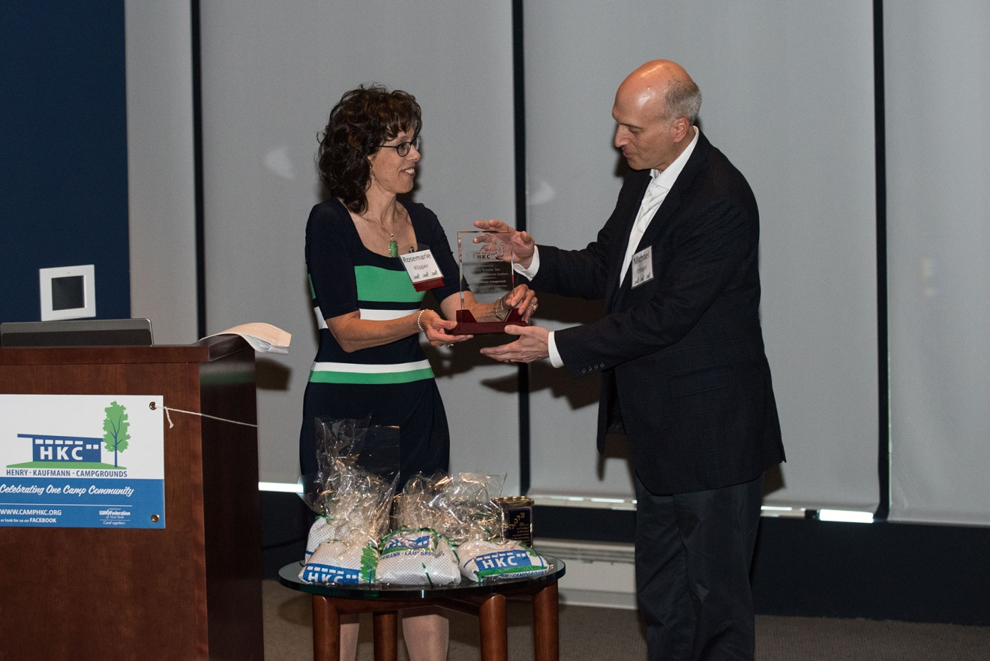

Michael S. Ettinger, Senior Vice President of Corporate & Legal Affairs, Henry Schein, Inc., accepted the Henry Kaufmann Campgrounds (HKC) Corporate Leader Award on behalf of Henry Schein. Rosemarie Klipper, HKC Board Member, presented the award on June 10 at the organization’s Annual One Camp Community Celebration held at Citi Field in New York City.

